Phase 1 System Design: Sandbox, Telemetry and Chaos Injector
Sep 30, 2026 · @RISHI R

Summary
Phase 1 builds the world the investigator will study: a small e-commerce system that emits full telemetry, a load generator that keeps it busy, a deploy tool that records every change, and a chaos injector that breaks it on purpose and records exactly what it broke.
Nothing in this phase is "AI". Its job is to produce realistic incidents with ground truth, so every later phase can be measured honestly.

Exit gate
Phase 1 is done when all of these hold:
- The whole sandbox starts with one command and reaches a healthy steady state in under 2 minutes.
- Five fault types can be injected from a YAML scenario, and each one visibly manifests in telemetry (checked automatically).
- Running the same scenario with the same seed twice produces an identical load schedule, an identical fault timeline and identical ground truth.
- Each run produces a self-contained run bundle (telemetry plus ground truth) that later phases can replay without the sandbox running.

Key design decisions
Decision | Choice | Why
Language | Python 3.12 everywhere, async-first | One language to master; asyncio models I/O-heavy services well
Service framework | FastAPI + uvicorn | Async, typed, auto-instrumented by OpenTelemetry
Network faults | Toxiproxy on every dependency edge | Inject latency, outages and resets without touching service code
Config faults | Real deploys through the deploy tool | Faults leave the same footprint a real bad deploy would
Ground truth | Separate database the investigator can never read | Prevents leaking answers into later phases
Telemetry storage | Grafana stack for humans, run bundles for machines | Visual debugging now, replayable datasets later
Reproducibility | Seeded load and fault schedules, validated by fingerprints | Telemetry values vary slightly run to run; the timeline must not

Architecture
Phase 1 has three planes. The data plane is the sandbox itself; the control plane drives traffic, deploys and faults into it; the telemetry plane captures everything the sandbox emits.
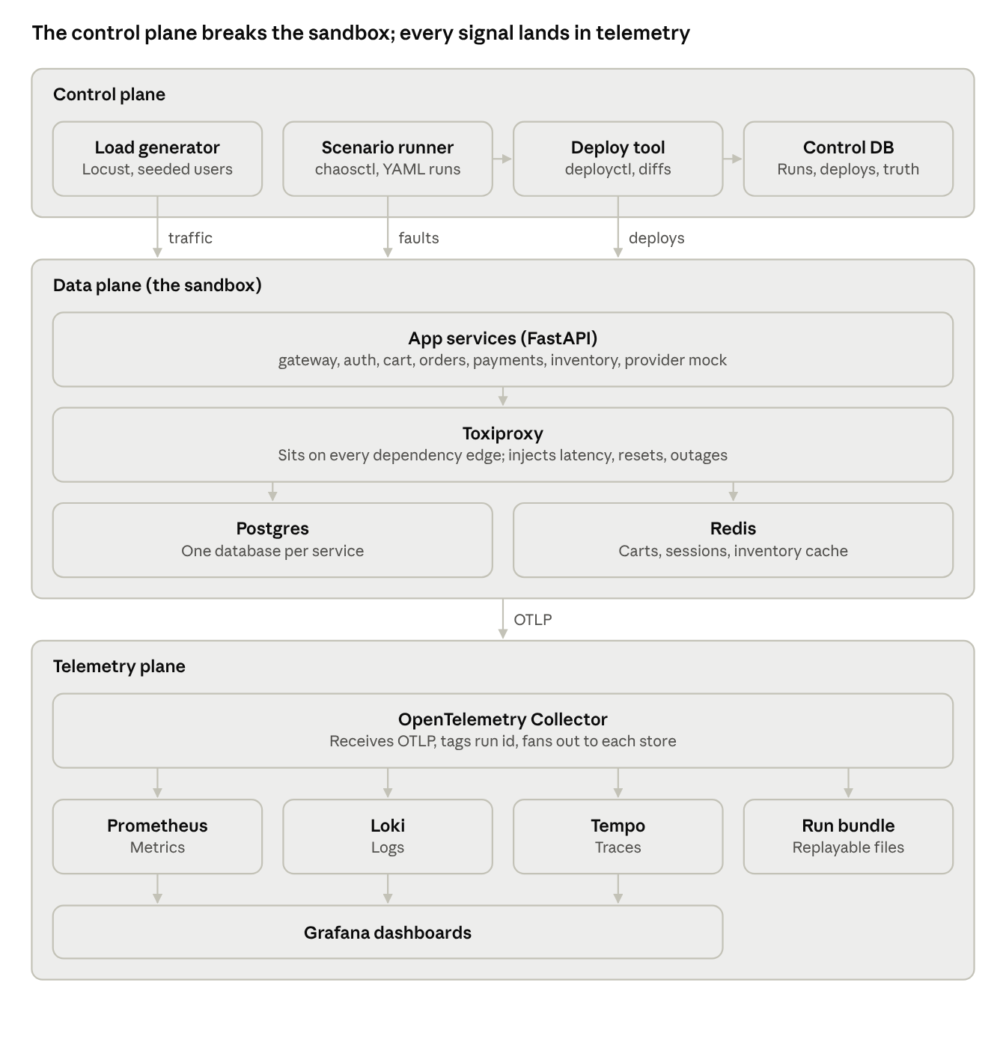
phase 1 architecture · 3 planes
The scenario runner orchestrates a run: it starts the load, calls the deploy tool for config faults, drives Toxiproxy and Docker for network and resource faults, and writes ground truth to the control DB. Services never know a run is happening; they just see traffic and failures, exactly as in production.

Network topology
- One Docker network, sandbox, for all services and dependencies.
- Services never talk to a dependency directly. Every dependency address points at a Toxiproxy listener, for example orders calls toxiproxy:18082 which forwards to payments:8000.
- The telemetry plane sits on its own network, observability; services reach the Collector only on OTLP port 4317.
- The control DB is reachable only from the control plane containers. Later phases get read access to runs and deploy events, never to the truth schema.

Tech stack
Everything is Python 3.12 or an off-the-shelf container; no component needs a second language. Versions are starting points to pin in uv.lock and docker-compose.yml.

Services and libraries
Tool | What it does | Where it is used
Python 3.12 + asyncio | Language and concurrency model | Every service, the load generator, chaosctl, deployctl
uv | Dependency and virtualenv management, one workspace for all packages | Repository root; each service is a workspace member
FastAPI + uvicorn | Async HTTP framework and server | All 7 app services
Pydantic v2 + pydantic-settings | Request models; typed config loaded from env and YAML | Service APIs, service config, scenario schema
httpx (async) | HTTP client with timeouts and connection pooling | Service-to-service calls, chaosctl talking to Toxiproxy
asyncpg | Async Postgres driver with a connection pool | orders, payments, inventory, auth; the pool is a fault surface
SQLAlchemy 2.0 Core + Alembic | Query building and schema migrations | Service databases and the control DB
redis-py (asyncio) | Async Redis client | cart, auth sessions, inventory cache
tenacity | Retries with backoff, configured per call site | Service clients; retry policy is a config knob
structlog | Structured JSON logs with trace context | Every service and control-plane tool
Typer | CLI framework | chaosctl and deployctl
Docker SDK for Python | Start, stop, restart, update containers | chaosctl (resource faults), deployctl (rollouts)
Locust | Load generation with Python user classes | Load generator container
pytest + pytest-asyncio | Unit, contract and scenario tests | All packages and the phase-gate suite

Infrastructure and telemetry
Tool | What it does | Where it is used
Docker Compose | Defines and runs the whole sandbox | deploy/compose/; one command brings everything up
Postgres 16 | Relational storage | Service databases (one per service) and the control DB (separate instance)
Redis 7 | In-memory store | Carts, sessions, inventory cache
Toxiproxy | TCP proxy with injectable toxics (latency, bandwidth, reset, timeout) | Between every service and each dependency
OpenTelemetry Python SDK + auto-instrumentation | Emits traces, metrics and logs | FastAPI, httpx, asyncpg and redis instrumentations in every service
OpenTelemetry Collector (contrib) | Receives, enriches, batches and routes telemetry | One collector container on the observability network
Prometheus | Metrics storage and queries | Receives metrics from the Collector via remote write
Grafana Loki | Log storage and queries | Receives logs from the Collector
Grafana Tempo | Trace storage and queries | Receives traces from the Collector
Grafana | Dashboards across all three | Human verification that faults manifest
GitHub Actions | CI | Lint, tests, and a nightly smoke scenario

Sandbox services
Seven small FastAPI services form a shop. Checkout is the critical path: it touches orders, inventory, payments and the provider mock, so most faults surface there first.
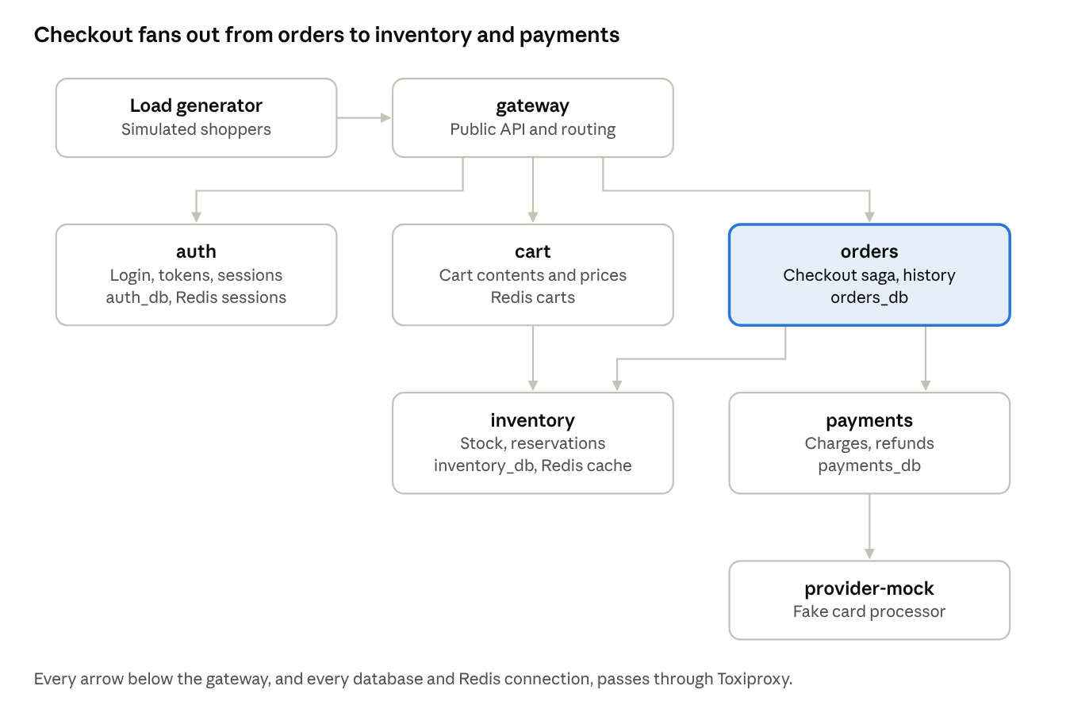
service call graph · 7 services
Each service owns its own database (a separate logical database on the shared Postgres instance) and never reads another service's tables. That keeps failures local and the dependency graph honest.

Service catalogue
Service | Responsibility | Key endpoints | Storage | Calls
gateway | Public entry point; validates tokens, routes, sets request ids | /api/* passthrough | None | auth, cart, orders
auth | Login, token issue and validation | POST /login, GET /validate | auth_db, Redis sessions | None
cart | Add, remove, view cart | GET/POST/DELETE /carts/{user} | Redis | inventory (price and stock lookup)
orders | Checkout saga, order history | POST /checkout, GET /orders/{user} | orders_db | inventory, payments
inventory | Stock levels, reservations | GET /items, POST /reserve, POST /release | inventory_db, Redis cache | None
payments | Charges and refunds, idempotent | POST /charge, POST /refund | payments_db | provider-mock
provider-mock | Fake external card processor with seeded latency and error rate | POST /authorize | None | None

The checkout flow
Checkout is a small saga: a sequence of local transactions with compensation if a later step fails.
- gateway receives POST /api/checkout with an Idempotency-Key header and forwards to orders.
- orders creates the order in state PENDING (or returns the existing order if the key was seen before).
- orders calls inventory /reserve. Inventory decrements stock inside a transaction using SELECT ... FOR UPDATE on each item row, so concurrent checkouts cannot oversell.
- orders calls payments /charge with the same idempotency key. Payments calls provider-mock and records the result.
- On success, orders marks the order CONFIRMED. On payment failure, orders calls inventory /release (the compensation step) and marks the order FAILED.

Config knobs (the fault surface)
Every resilience setting lives in versioned config, not code. Bad values here are the raw material for config faults.
Knob | Service | Default | Fault it enables
db.pool_min / db.pool_max | orders, payments, inventory, auth | 5 / 20 | Pool starvation after a bad deploy
db.acquire_timeout_ms | same | 1000 | Fast failures vs long queues
http.timeout_ms per dependency | every caller | 800 | Cascading timeouts
http.retries / http.backoff_ms | every caller | 2 / 100 | Retry storms (phase 6)
cache.ttl_s | inventory | 30 | Cache miss storms
cache.enabled | inventory | true | Database load spike
provider.latency_ms_p50 / provider.error_rate | provider-mock | 120 / 0.01 | Slow or flaky external dependency

Shared service conventions
- A common package, sandbox_common, provides config loading, logging setup, OpenTelemetry setup, DB pool and HTTP client factories, so every service behaves identically.
- GET /healthz (process alive) and GET /readyz (dependencies reachable) on every service; Compose health checks use /readyz.
- Graceful shutdown: stop accepting requests, drain in-flight ones for up to 10 s, close pools.
- Memory limits in Compose (mem_limit: 256m) so a leak ends in a real OOM kill and restart.
- A chaos admin router (/_chaos/*) is mounted only when SANDBOX_CHAOS_HOOKS=1; it supports only the memory-leak fault and the log-noise red herring.

Telemetry design
Telemetry is the investigator's only window into the sandbox, so it must be rich, consistent across services, and tagged with the run it belongs to. All three signals flow over OTLP to one Collector.

Instrumentation
- sandbox_common.telemetry.setup(service_name) configures the OpenTelemetry SDK once per service: tracer, meter and logger providers, all exporting OTLP gRPC to otel-collector:4317.
- Auto-instrumentation covers FastAPI (server spans), httpx (client spans), asyncpg (DB spans) and redis (cache spans). Trace context propagates with W3C traceparent headers.
- Custom spans wrap each checkout saga step (checkout.reserve, checkout.charge, checkout.compensate) so traces show business steps, not just HTTP calls.
- Sampling is 100% (parent-based) in phase 1. Sandbox volume is low, and later phases need complete traces for ground truth. Revisit if storage grows.

Resource attributes (on every signal)
Attribute | Example | Set by
service.name | payments | Service at startup
service.version | 1.4.2+cfg.7 | Deploy tool, via env (code version + config version)
deployment.environment | sandbox | Compose env
sandbox.run_id | run-2026-09-30-0007 | Scenario runner at reset, via env and the Collector's resource processor

Log conventions
- structlog renders JSON to stdout and, through the OpenTelemetry logging bridge, to OTLP.
- Required fields: timestamp (RFC 3339, ns), level, event (a stable snake_case name such as db_pool_acquire_timeout), message, trace_id, span_id.
- Messages are human sentences with the variable parts inline, for example Timed out acquiring DB connection after 1000 ms (pool_max=5, waiting=37). Phase 3's log templating needs exactly this kind of text to learn from.
- Errors add error.type, error.message and the stack trace as exception.stacktrace.
- Never log secrets, tokens or full card numbers; the provider mock uses fake card data only.

Metrics
Metric | Type | Source | Why it matters
http.server.request.duration | Histogram | FastAPI auto-instrumentation | Latency and error rate per route (RED metrics)
http.client.request.duration | Histogram | httpx auto-instrumentation | Per-dependency latency from the caller's view
sandbox.db.pool.in_use / idle / waiting | Gauges | sandbox_common pool wrapper | Pool starvation shows up here first
sandbox.db.pool.acquire.duration | Histogram | Pool wrapper | Time spent waiting for a connection
sandbox.cache.requests | Counter, `result=hit | miss` | Inventory cache layer
sandbox.checkout.outcomes | Counter, `outcome=confirmed | failed | compensated`
process.memory.usage, process.cpu.utilization | Gauges | OpenTelemetry system metrics | Leaks and CPU throttling
sandbox.retry.attempts | Counter | tenacity hook | Retry amplification
Metrics export every 5 s. Latency histograms use explicit buckets from 5 ms to 10 s so p99 shifts are visible.

Collector pipeline
receivers:
otlp:
protocols: { grpc: { endpoint: 0.0.0.0:4317 } }
processors:
memory_limiter: { check_interval: 1s, limit_mib: 512 }
resource:
attributes:
- { key: sandbox.run_id, value: ${env:SANDBOX_RUN_ID}, action: upsert }
batch: { timeout: 2s }
exporters:
prometheusremotewrite: { endpoint: http://prometheus:9090/api/v1/write }
otlphttp/loki: { endpoint: http://loki:3100/otlp }
otlp/tempo: { endpoint: tempo:4317, tls: { insecure: true } }
file/bundle:
path: /bundles/current/telemetry.jsonl
rotation: { max_megabytes: 100 }
service:
pipelines:
metrics: { receivers: [otlp], processors: [memory_limiter, resource, batch], exporters: [prometheusremotewrite, file/bundle] }
logs: { receivers: [otlp], processors: [memory_limiter, resource, batch], exporters: [otlphttp/loki, file/bundle] }
traces: { receivers: [otlp], processors: [memory_limiter, resource, batch], exporters: [otlp/tempo, file/bundle] }

Run bundles
A run bundle is a self-contained folder that captures one run, so later phases can develop and test against recorded incidents without the sandbox running.
bundles/run-2026-09-30-0007/
manifest.json run id, seed, scenario hash, git SHA, start and end times, checksums
scenario.yaml the exact scenario that ran
load_schedule.jsonl every planned user action with its offset (from the seed)
telemetry/ traces, metrics and logs as OTLP JSON lines, zstd-compressed
deploy_events.jsonl deploys and config changes with diffs
truth/
ground_truth.json what was injected, where, when, and what it caused
fingerprints.json measured evidence that each fault manifested
The truth/ folder is only ever read by the eval harness. Loaders used by agents in later phases refuse to open it.

Dashboards
Grafana is provisioned from files in deploy/grafana/ with four dashboards: service overview (rate, errors, duration per service), dependencies (per-edge latency), resources (pools, cache, memory, CPU) and checkout funnel. These are for you to confirm by eye that a fault really happened.

Load generator
The load generator plans all traffic from a seed before the run starts, then Locust replays that plan. Planning first is what makes the load identical across runs; Locust's own random spawning is not reproducible.

Two steps: plan, then replay
- loadgen plan --seed 42 --profile default --duration 20m writes load_schedule.jsonl: one line per virtual user session with its start offset, journey type, user id, items and idempotency keys.
- A custom Locust LoadTestShape plus a ScheduledUser class read the schedule and start each session at its offset. Each session runs its journey step by step against the gateway.

Journeys
Journey | Share | Steps
Browse | 50% | List items, view 1–5 items
Cart | 25% | Log in, add 1–3 items, view cart, sometimes remove one
Checkout | 15% | Log in, add items, view cart, checkout with an idempotency key
Account | 10% | Log in, view order history

Traffic shape
- Session arrivals follow a Poisson process around a baseline of about 20 requests per second.
- A compressed daily cycle: a 20-minute sine wave of plus or minus 30% so incidents happen at both busy and quiet times.
- Seeded bursts: occasional 2x spikes lasting 30–60 s, planned in the schedule and recorded in the bundle so they are never confused with faults.
- Item popularity follows a Zipf distribution: a few hot items get most traffic. This gives the inventory cache something to do and creates real row-lock contention on hot items during checkout.

Test data
- loadgen seed-data --seed 42 loads 1,000 users and 500 items with stock levels into the service databases before each run.
- Stock is high enough that sold-out items are rare unless a scenario wants them.

Client-side results
Locust records every request's outcome and latency from the user's point of view to loadgen_results.jsonl in the bundle. This is the ground truth for user-visible impact, separate from what services report about themselves.

Deploy tool
deployctl is the only way anything changes in the sandbox. Every change, good or bad, becomes a real git commit plus a recorded deploy event, so bad-config faults leave exactly the footprint a real bad deploy would.

Config repository
- sandbox-config/ is its own git repository with one file per service: services/<name>/config.yaml holding every knob from the config knob table.
- Services mount their config file read-only and load it at startup. Changing config therefore requires a deploy (a restart), just like production.
- service.version combines the code image tag and the config commit, for example 1.4.2+cfg.7.

Commands
Command | What it does
deployctl deploy <service> --set key=value ... -m "<message>" | Edits config, commits, rolls out, records the event
deployctl deploy <service> --image <tag> | Rolls out a new code image with the current config
deployctl rollback <service> | Deploys the previous version as a new, recorded deploy
deployctl history [<service>] | Lists recorded deploys

Rollout sequence
- Validate the new config against the service's Pydantic settings model; reject invalid values before anything changes.
- Commit to sandbox-config with a seeded, realistic author and the given message.
- Record a deploy_started event.
- Recreate the container with the Docker SDK (single replica per service in phase 1, so there is a brief restart).
- Poll /readyz until healthy or a 60 s timeout.
- Record deploy_completed or deploy_failed, including duration.

What gets recorded
Each deploy is written to three places: the deploy_events table in the control DB, an OpenTelemetry log event (event=deploy_completed) so it appears in the telemetry stream like a real deploy marker, and deploy_events.jsonl in the run bundle.
Field | Example
service, from_version, to_version | payments, 1.4.2+cfg.6, 1.4.2+cfg.7
config_sha_before / after | Git SHAs in sandbox-config
image_before / after | Container image tags
diff | Unified git diff of the config change
changed_keys | [{key: db.pool_max, old: 20, new: 5}]
author, message | priya.k, Reduce payments DB pool to cut idle connections
started_at, finished_at, status | Timestamps and outcome

No giveaways
Nothing in a deploy event may reveal whether it is a fault. Authors come from a seeded pool of fake engineer names, messages read like real commit messages, and scenarios also schedule harmless deploys (log level changes, a raised timeout, a version bump) so "a deploy happened" is never on its own the answer.

Chaos injector
chaosctl runs scenarios: it schedules faults on a timeline, drives the right mechanism for each one, records ground truth the moment each fault starts and stops, and afterwards proves each fault actually showed up in telemetry.

Components
Component | Responsibility
Scenario loader | Parses YAML into Pydantic models; rejects unknown fault types, bad targets and overlapping faults on the same edge
Timeline scheduler | An asyncio task that fires fault start and stop events at their offsets from run start, using a monotonic clock
Fault drivers | One class per fault type; each knows how to inject, revert and describe its fault
Ground truth writer | Writes a record to the truth schema at each inject and revert, with actual wall-clock timestamps
Fingerprint checker | After the run, queries Prometheus and Loki to confirm each fault manifested; writes fingerprints.json
Safety net | Reverts every active fault on success, error, Ctrl-C or SIGTERM (try/finally plus signal handlers); chaosctl reset clears everything by hand

Fault driver interface
class FaultDriver(Protocol):
fault_type: ClassVar[str]
async def inject(self, params: FaultParams) -> FaultHandle: ...
async def revert(self, handle: FaultHandle) -> None: ...
def ground_truth(self, params: FaultParams) -> GroundTruthSpec: ...
def fingerprint_checks(self, params: FaultParams) -> list[FingerprintCheck]: ...
New fault types are added by writing one driver class and registering it; the scheduler and ground truth logic never change.

Phase 1 fault catalogue
Fault type | Mechanism | Example params | Expected footprint (fingerprint)
bad_config_deploy | deployctl deploy with a harmful value | service: payments, set: {db.pool_max: 2} | Pool waiting up, acquire timeouts in logs, payments p99 at least 3x baseline
slow_dependency | Toxiproxy latency toxic on one edge | edge: payments->provider, latency_ms: 1500, jitter_ms: 300 | Client latency on that edge up; timeouts upstream
dependency_outage | Toxiproxy proxy disabled, or container stopped via Docker SDK | edge: orders->inventory | Connection refused or reset errors; checkout failures
cache_stampede | Flush inventory cache keys in Redis under load | service: inventory | Cache miss ratio spike; inventory DB query rate and latency up
memory_leak | POST /_chaos/leak on the target, allocating a set MB per second | service: cart, rate_mb_s: 2 | Memory climbs to the limit, OOM kill, restart, error burst
Stretch for phase 1 if time allows: noisy_neighbour (CPU quota cut with docker update). Retry storms, disk exhaustion and compound faults come in phase 6.

Red herrings (supported from day one)
- benign_deploy: a harmless config change through deployctl, timed near the real fault.
- log_noise: POST /_chaos/noise makes a service emit a new, harmless warning template at a set rate.
- Both are recorded in ground truth with role: red_herring, so the eval harness knows what the investigator should rule out.

What the investigator can and cannot see
Toxiproxy and Redis faults leave no event anywhere; they are visible only through their effects, as in real life. Config faults leave a deploy event, as a real bad deploy would. Ground truth, fault driver logs and the chaos admin calls are never part of the telemetry stream: the chaos routes are excluded from instrumentation, and chaosctl logs to its own file, not the Collector.

Scenario spec and run lifecycle
A scenario is one YAML file that fully describes a run: the seed, the traffic, the timeline, the faults and the red herrings. Running it is one command: chaosctl run scenarios/payments-pool-starvation-01.yaml.

Scenario format
id: payments-pool-starvation-01
description: Payments DB pool shrunk by a deploy; unrelated inventory warning as a red herring
seed: 42
load:
profile: default # journey mix and traffic shape
baseline_rps: 20
timeline: # windows run in this order
warmup: 3m # caches fill; never scored
baseline: 5m # normal behaviour, used for fingerprint baselines
observe: 10m # faults fire inside this window
recovery: 5m # faults reverted, system settles
faults:
- id: f1
type: bad_config_deploy
role: root_cause
at: 2m # offset from the start of the observe window
params:
service: payments
set: { db.pool_max: 2 }
message: "Reduce payments DB pool to cut idle connections"
revert: at_end # or a duration such as 6m
red_herrings:
- id: r1
type: log_noise
at: 1m30s
params:
service: inventory
message: "Price index warm-up slower than expected, continuing"
rate_per_s: 2
expectations: # copied into ground truth for scoring
impacted_services: [payments, orders, gateway]
Scenarios live in scenarios/, one folder per fault type. Phase 1 needs at least one scenario per fault type plus two with red herrings; the full 50-scenario suite is built in phase 5.

Run lifecycle
- Prepare. Validate the scenario, allocate a run id, insert a runs row with status preparing, and generate the load schedule from the seed.
- Reset. Tear down the data plane with its volumes, reset sandbox-config to the baseline tag, and start everything fresh with SANDBOX_RUN_ID set. Wait for every /readyz.
- Seed data. Load users and items from the seed.
- Warm-up. Start the load replay. Nothing is scored.
- Baseline. Normal traffic; the runner records the window's start and end.
- Observe. The timeline scheduler fires faults and red herrings at their offsets; ground truth is written at each inject and revert.
- Recovery. Remaining faults are reverted; the system is watched as it settles.
- Finalise. Stop the load, wait for the Collector to flush (batch timeout plus 5 s), move telemetry into the bundle, write the manifest and checksums, run fingerprint checks, and mark the run complete or invalid.
A run is invalid if any root-cause fault fails its fingerprint check. Invalid runs are kept for debugging but never used for evaluation.

Run states
preparing → resetting → running → finalising → complete | invalid | aborted. The state is stored in the runs table, so chaosctl status and later phases can see progress, and an aborted run's cleanup is always attempted.

Data model
The control DB is a separate Postgres instance with two schemas. control holds what later phases may read (runs, deploys); truth holds the answers and is readable only by the chaos tooling and the eval harness. Database roles enforce the split, not convention.
CREATE SCHEMA control;
CREATE SCHEMA truth;
-- One row per scenario run
CREATE TABLE control.runs (
run_id text PRIMARY KEY, -- run-2026-09-30-0007
scenario_id text NOT NULL,
scenario_hash text NOT NULL, -- sha256 of the YAML
seed bigint NOT NULL,
git_sha text NOT NULL, -- code version of the sandbox
status text NOT NULL, -- preparing | resetting | running | finalising | complete | invalid | aborted
windows jsonb NOT NULL DEFAULT '{}', -- actual start/end of warmup, baseline, observe, recovery
bundle_path text,
created_at timestamptz NOT NULL DEFAULT now(),
finished_at timestamptz
);
-- Every deploy, harmful or harmless (visible to the investigator later)
CREATE TABLE control.deploy_events (
deploy_id uuid PRIMARY KEY,
run_id text REFERENCES control.runs,
service text NOT NULL,
from_version text NOT NULL,
to_version text NOT NULL,
config_sha_before text NOT NULL,
config_sha_after text NOT NULL,
image_before text NOT NULL,
image_after text NOT NULL,
diff text NOT NULL,
changed_keys jsonb NOT NULL, -- [{key, old, new}]
author text NOT NULL,
message text NOT NULL,
status text NOT NULL, -- started | completed | failed
started_at timestamptz NOT NULL,
finished_at timestamptz
);
CREATE INDEX ON control.deploy_events (service, started_at);
-- What was actually injected (hidden)
CREATE TABLE truth.injections (
injection_id uuid PRIMARY KEY,
run_id text NOT NULL REFERENCES control.runs,
spec_id text NOT NULL, -- f1, r1 from the YAML
fault_type text NOT NULL,
role text NOT NULL, -- root_cause | red_herring
target_service text,
target_edge text, -- payments->provider
params jsonb NOT NULL,
deploy_id uuid REFERENCES control.deploy_events, -- set for config faults
injected_at timestamptz NOT NULL,
reverted_at timestamptz
);
-- Expected impact and fingerprint results (hidden)
CREATE TABLE truth.outcomes (
run_id text PRIMARY KEY REFERENCES control.runs,
impacted_services text[] NOT NULL,
fingerprints jsonb NOT NULL, -- [{injection_id, check, baseline, observed, passed}]
manifested boolean NOT NULL
);
-- Access control
CREATE ROLE chaos_rw; -- chaosctl, deployctl, eval harness
CREATE ROLE investigator; -- used by agents from phase 4 on
GRANT USAGE ON SCHEMA control TO investigator;
GRANT SELECT ON control.runs, control.deploy_events TO investigator;
-- no grants on schema truth for investigator
Migrations are managed with Alembic in control_db/migrations/. Each service's own database has its own Alembic migrations inside the service package.

Reproducibility
A real distributed system never produces byte-identical telemetry twice, so "reproducible" has a precise meaning here: the plan repeats exactly, and the effects repeat within tolerance.
Must be identical | Must match within tolerance
Load schedule (file hash) | Fault injection times: within 1 s of the planned offset
Seed data | Baseline p50 and p99 latency per service: within 20%
Fault and red herring timeline (offsets, params) | Fingerprint checks: every root-cause check passes in both runs
Ground truth, with timestamps converted to offsets | Request counts per journey: within 5%
Deploy diffs, changed keys, authors and messages

Controlling randomness
- One seed, many streams. sandbox_common.rng(namespace) derives an independent generator from hash(seed, namespace), for example rng("loadgen.arrivals") or rng("deploy.authors"). Adding a new consumer never shifts anyone else's random sequence.
- No hidden randomness. Code never calls random.random() or uuid4() for anything that ends up in the plan or the ground truth; ids there are uuid5(run_seed, spec_id).
- Relative time. The scheduler works in offsets from the run's monotonic start, never wall-clock times.
- Fresh state. Every run starts from empty volumes and the baseline config tag, so nothing leaks between runs.
- Pinned images. Third-party images (Postgres, Redis, Toxiproxy, Collector, Grafana stack) are pinned by digest.
- Accepted variation. The provider mock draws latencies from a seeded distribution, but which request gets which draw depends on arrival order. That variation is expected and is exactly why the tolerance column exists.

The check
chaosctl verify-repro <scenario> --runs 2 runs the scenario twice and compares the two bundles against both columns above. It exits non-zero on any mismatch and prints which item failed. This command is the phase gate's reproducibility test.

Repository layout
One monorepo, managed as a uv workspace, so every service and tool shares sandbox_common and one lockfile.
incident-investigator/
pyproject.toml uv workspace root
uv.lock
Makefile init, up, down, test, run SCENARIO=...
packages/
sandbox_common/ config, logging, telemetry, rng, db pool and http client factories, chaos hooks
services/
gateway/ auth/ cart/ orders/ inventory/ payments/ provider_mock/
src/<service>/ FastAPI app, routes, domain logic
migrations/ Alembic (services with a database)
tests/
Dockerfile
tools/
chaosctl/ scenario loader, scheduler, fault drivers, fingerprints, bundle writer
deployctl/ config commits, rollouts, deploy events
loadgen/ planner, Locust user and shape, seed-data
control_db/
migrations/ Alembic for the control and truth schemas
config-baseline/ baseline config.yaml per service; copied into sandbox-config/ by make init
sandbox-config/ separate git repo created at init (git-ignored here)
scenarios/
bad_config_deploy/ slow_dependency/ dependency_outage/ cache_stampede/ memory_leak/
deploy/
compose/ docker-compose.yml, networks, health checks, memory limits
otel-collector/ collector config
grafana/ datasources and dashboards (provisioned)
prometheus/ loki/ tempo/
bundles/ run bundles (git-ignored)
tests/
gate/ phase gate tests (manifestation and reproducibility)
.github/workflows/ CI

Testing and the phase gate
Tests run at four levels, from fast unit tests on every commit up to full scenario runs that prove the gate.
Level | What it covers | Runs
Unit | Domain logic (saga steps, reservations), scenario parsing, rng derivation, fault driver param validation | Every commit, in CI, seconds
Service integration | Each service against real Postgres and Redis in containers; checkout saga including compensation; SELECT ... FOR UPDATE under concurrent reservations | Every commit, in CI, a few minutes
Contract | Each caller's client matches the callee's OpenAPI schema | Every commit, in CI
Scenario (gate) | Full runs: every fault manifests; reproducibility holds | Nightly in CI (smoke scenario) and on demand locally (all)

Worth-it tests to write early
- Oversell test. 200 concurrent checkouts for an item with 50 in stock must produce exactly 50 confirmed orders.
- Idempotency test. Replaying the same checkout with the same key 10 times produces one order and one charge.
- Compensation test. Force a payment failure; stock must return to its original level.
- Safety-net test. Kill chaosctl mid-fault; chaosctl reset must leave no toxics, no leak and baseline config.

Gate checklist
- ☐ make up brings the sandbox to healthy in under 2 minutes on a clean machine
- ☐ Grafana shows all four dashboards populated under normal load
- ☐ One scenario per fault type runs to complete with all fingerprints passing
- ☐ Two red-herring scenarios run to complete, with red herrings visible in telemetry
- ☐ chaosctl verify-repro passes for every fault type
- ☐ Each run produces a bundle that loads offline and matches its manifest checksums
- ☐ The investigator role cannot read anything in the truth schema (tested)

Build plan
This design is realistically about three weeks of part-time work, one more than the requirements roadmap allowed. To hold to two weeks, drop the red herrings and the provider mock's latency model to phase 6 and keep everything else.
Each week ends with something that runs end to end, so you are never more than a few days from a working system.

Week 1: a shop that runs and is observable
- ☐ Set up the uv workspace, sandbox_common (config, logging, telemetry, rng) and CI with lint and unit tests
- ☐ Build auth, cart, inventory and gateway with their databases and migrations
- ☐ Build orders with the checkout saga, and payments plus the provider mock
- ☐ Write the oversell, idempotency and compensation tests
- ☐ Write Compose with health checks, memory limits and Toxiproxy on every edge
- ☐ Stand up the Collector, Prometheus, Loki, Tempo and Grafana; confirm one trace spans gateway to provider mock
- ☐ Add the custom metrics (pool, cache, checkout outcomes, retries)
End of week demo: make up, click through the shop with curl, and see the checkout trace and metrics in Grafana.

Week 2: traffic and deploys
- ☐ Build the loadgen planner, seed-data and the Locust replay user and shape
- ☐ Build the control DB with both schemas, roles and migrations
- ☐ Build deployctl (config repo, validation, rollout, deploy events in all three places)
- ☐ Provision the four Grafana dashboards
- ☐ Write the Collector file exporter and the bundle writer with manifest and checksums
End of week demo: 20 minutes of steady seeded traffic, a manual bad deploy that you watch hurt payments in Grafana, and a bundle on disk.

Week 3: chaos and the gate
- ☐ Build chaosctl: scenario loader, timeline scheduler, run lifecycle and run states
- ☐ Write the five fault drivers and the two red-herring drivers, with the safety net and chaosctl reset
- ☐ Write the fingerprint checks per fault type
- ☐ Write the scenarios: one per fault type plus two with red herrings
- ☐ Build chaosctl verify-repro and the gate tests
- ☐ Work through the gate checklist
End of week demo: one command runs a scenario, the fault shows up in Grafana, and the bundle's ground truth and fingerprints say exactly what happened.

Hand-off to later phases
Phase 1's outputs are designed so each later phase plugs in without reworking the sandbox.
Later phase | What it takes from phase 1 | Change needed then
2: runtime | Nothing required; bundles can be used as realistic test inputs for fake agents | None
3: ingestion and retrieval | Live OTLP stream; bundles for offline development; control.deploy_events for the change index | Add a Kafka exporter to the Collector; add bundlectl replay <bundle> --to kafka --speed 10x
4: agents | The investigator database role; the Toxiproxy-free view of the world (effects only) | None
5: evaluation | truth schema, bundle truth/ folders, fingerprints, the scenario library | Grow the library to 50+ scenarios
6: depth | Fault driver interface | New drivers: retry storm, noisy neighbour, disk exhaustion, compound faults
Future code integration | deployctl --image already records code image changes | Code-level fault drivers that deploy buggy images

Open questions
- ☐ Is your machine large enough for about 20 containers? If not, run Loki and Tempo only when debugging and rely on bundles otherwise.
- ☐ One replica per service (simple, brief restart on deploy) or two replicas for gateway and orders (rolling deploys, more realistic)?
- ☐ A default run takes about 23 minutes. Add a fast profile (1 m warm-up, 2 m baseline, 5 m observe, 2 m recovery) for day-to-day iteration?
- ☐ How many bundles to keep locally, and whether to push completed bundles to object storage later.

